How to prevent others connect to my WiFi by Access Control
Product line: wireless question category: function config

Sometimes we find that somebody is using our wireless network without permission. In order to get rid of this situation, we can enable Wireless Access Control.

The Steps are as below:
1. Check out the MAC Address of the computers which you are allowed or not to connect to your WiFi.
Click StartàRun. Type cmd and press Enter on the computer
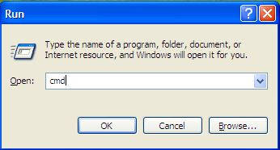

Type ipconfig /all at the prompt window, press Enter, it will show the MAC address and other address information of this computer.
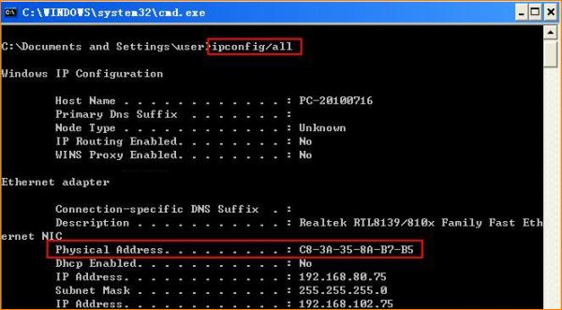

2. Login to the management page of the router.
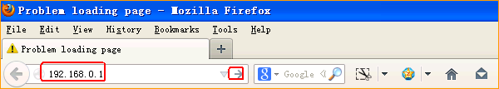

- Input login password admin(default), to login, then click Advanced
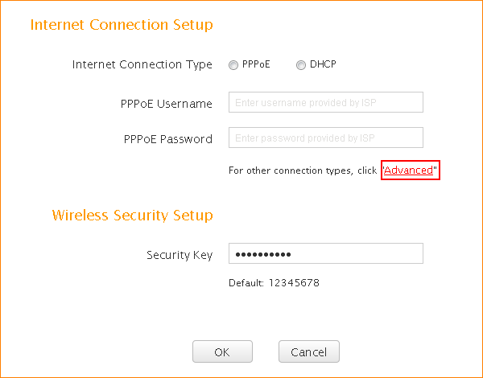

- Click on Wireless, then click on Access Control.

If you only want your family to connect to your WiFi, you can add the MAC Address of their computers to the list one by one,as the following picture.
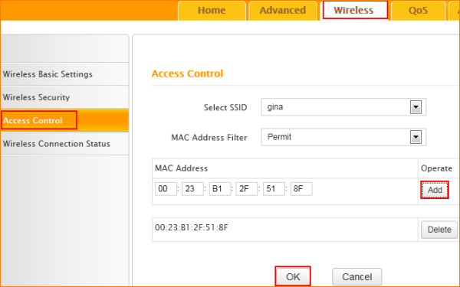

If you only want to forbid the device with the MAC Address 23:75:F5:B6:8C:EC to connect to your WiFi, you can do the settings as the following picture.

